DASA PROJECT

REPORT

Team

**Trần Thanh Duy**

**Nguyễn Nho dũng**

**Part 1: Requirement of application**

See in the file project.pdf

**Part 2: Application structure (suggestion)**

**Back-end side Google Drive, Dropbox, SkyDrive**

**CLOUD**

**REST**

Each user has only token when he/she registers API. And, the server archives this token for authorization (The token is secret and nobody can’t share with others people)

**Part 2: Framework and Library**

org.scribe: the simple OAuth for Java lib

**Part 3: REST API**

In this project, our team use 3 types of API: Google Drive API, Dropbox API and Sky Drive API (Sky Drive is a cloud application of Microsoft)

**Part 4: Some screenshots**

API key of Google and Dropbox

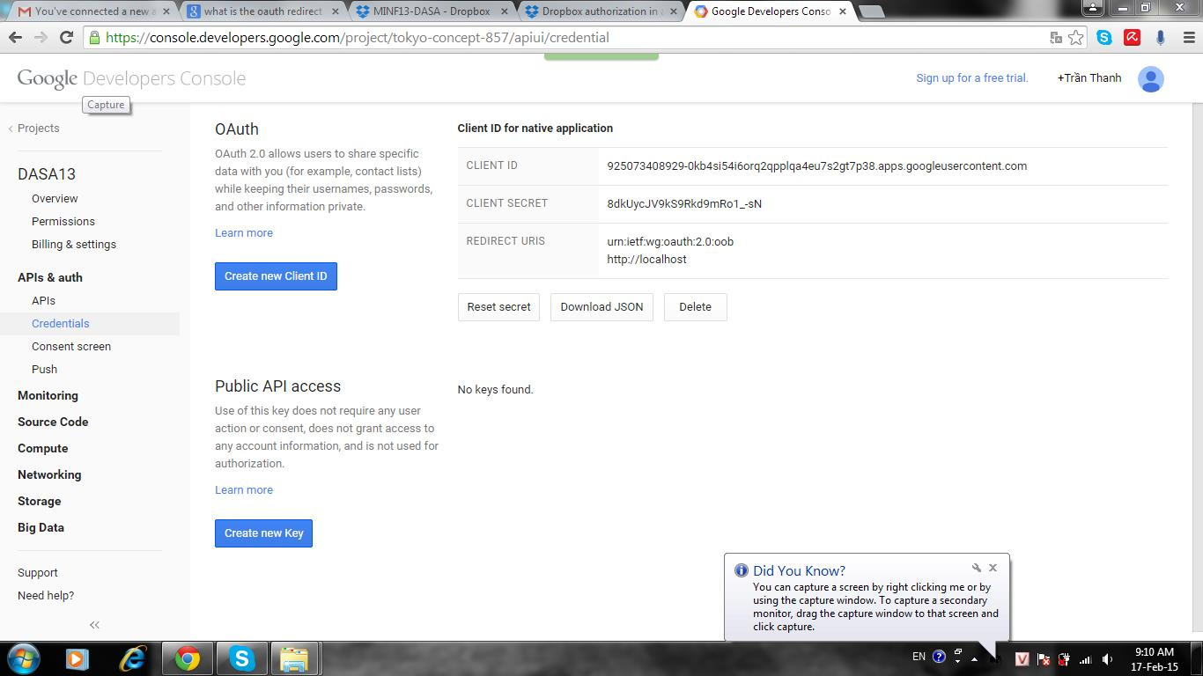

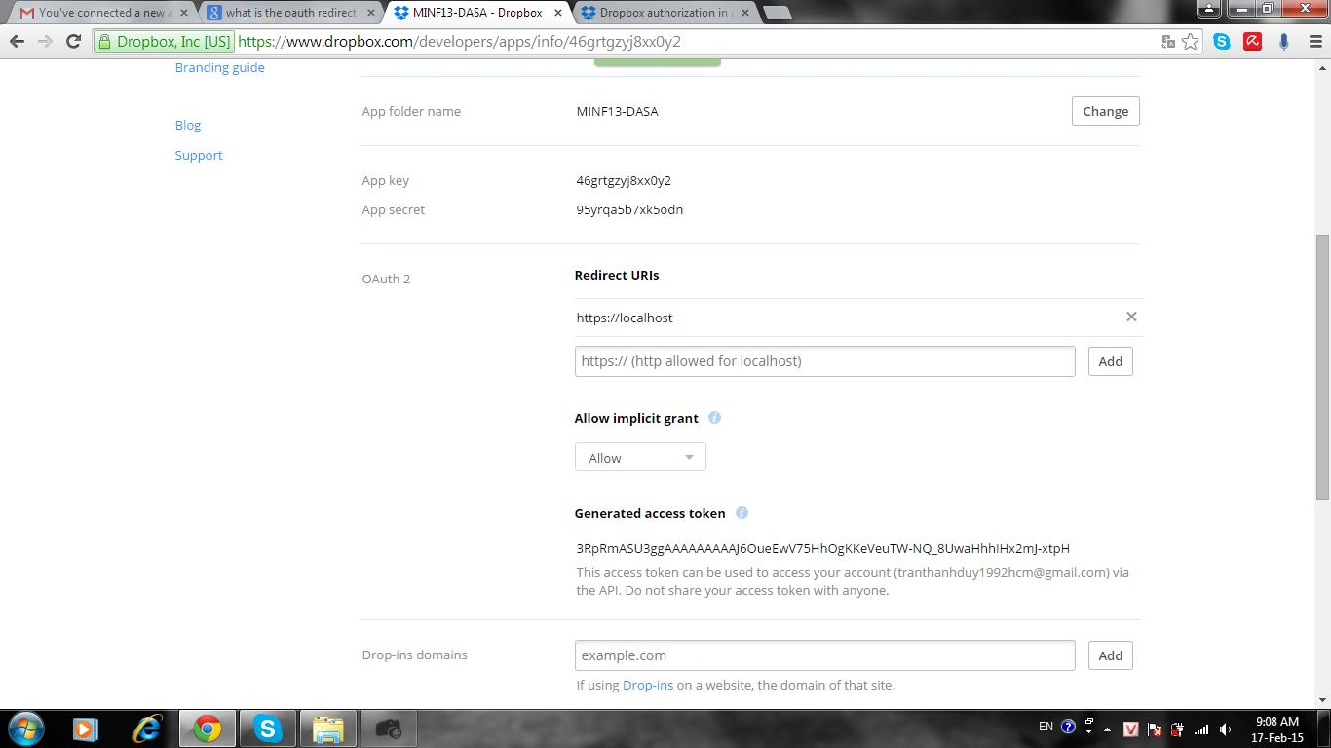

Get code from Google Drive

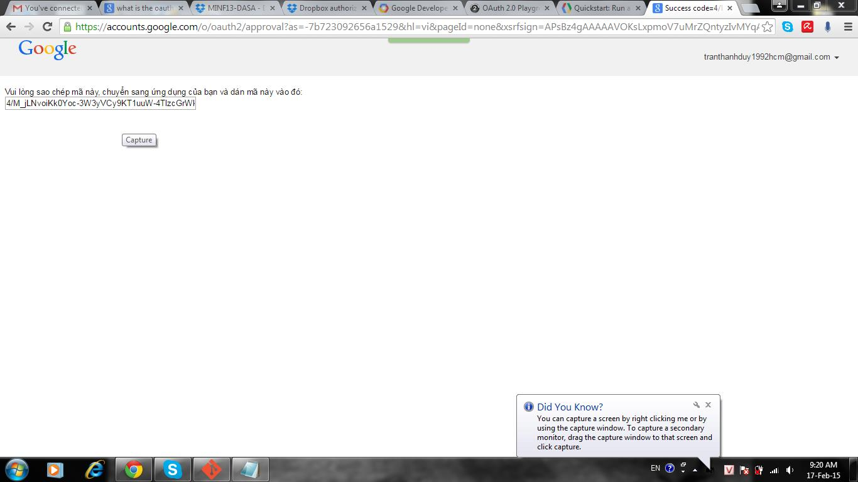

Authorization page from Google

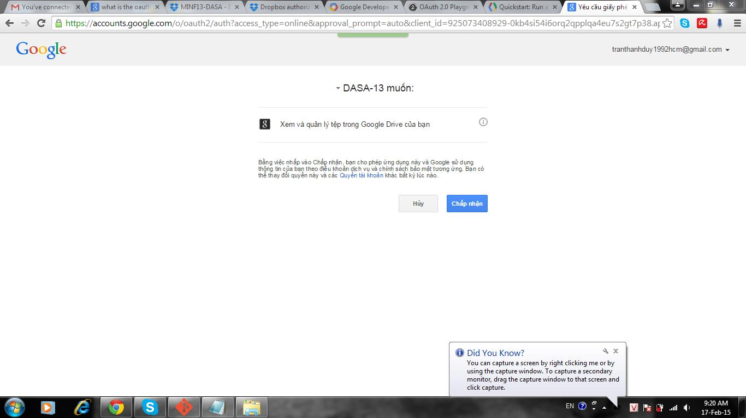

Get token from Google Drive (access to OAuth playground of Google)

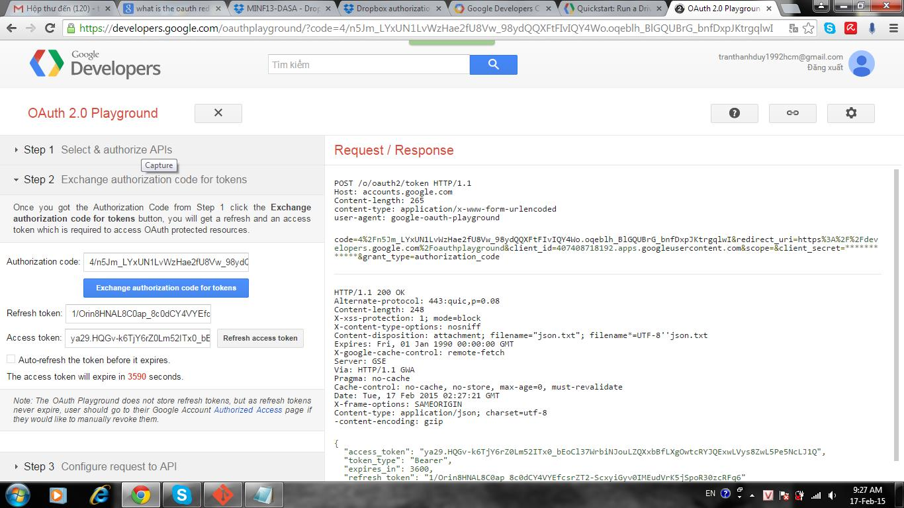

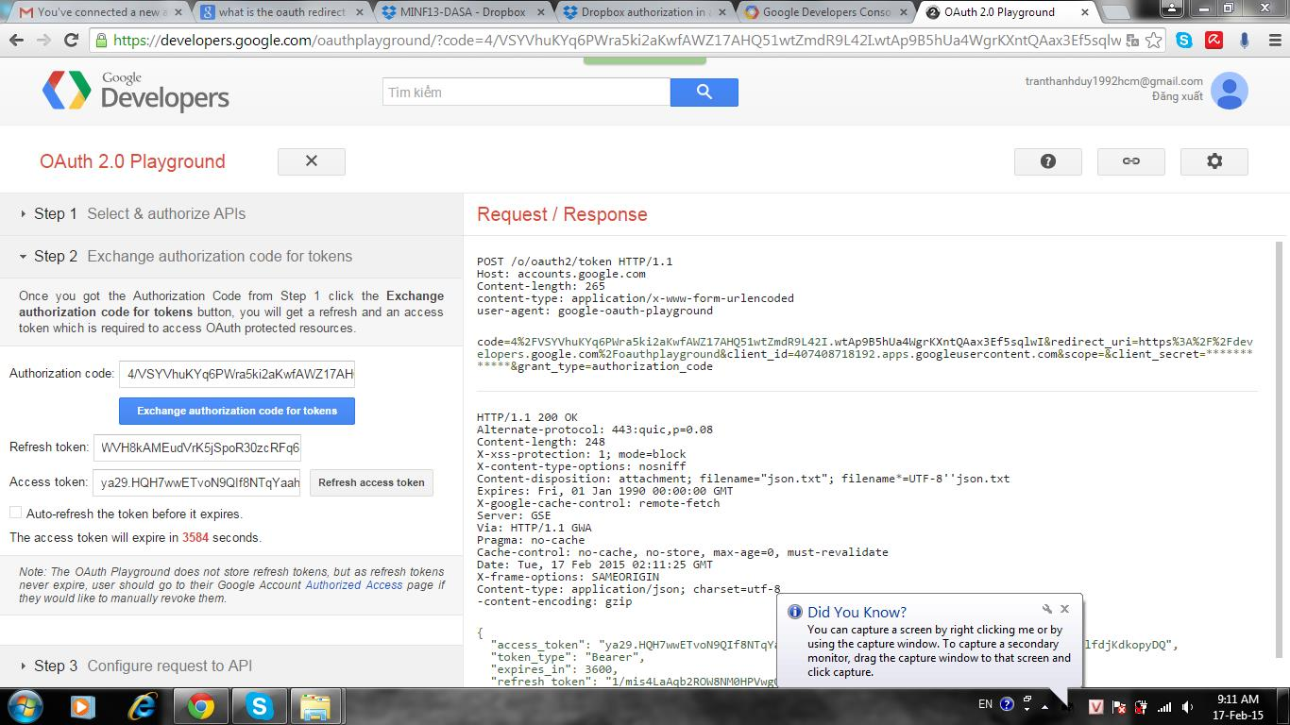

Get file from Drive

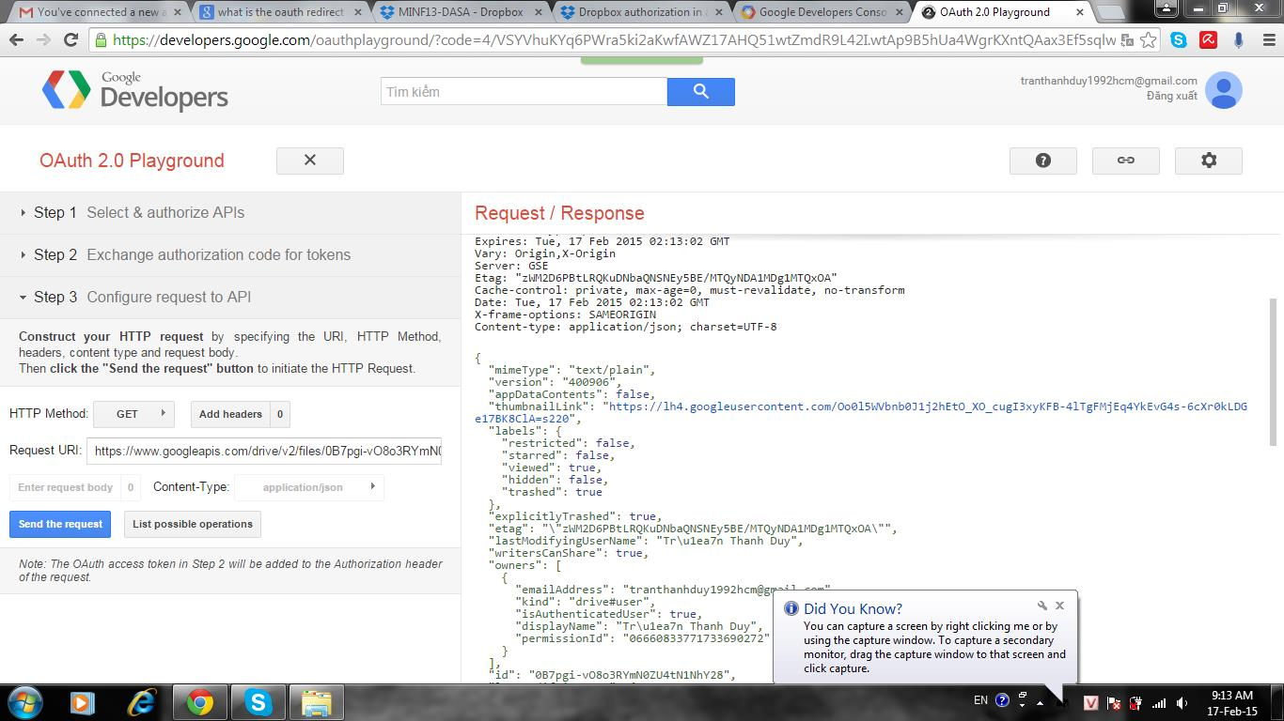

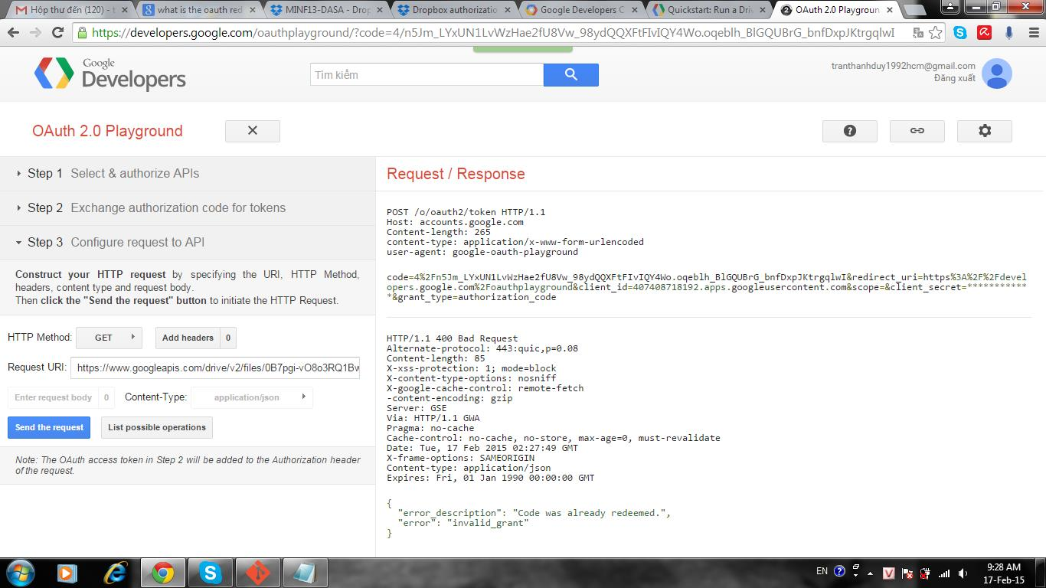

Test result (test on Google Drive)

Step 1: Get file information (from Google Drive)

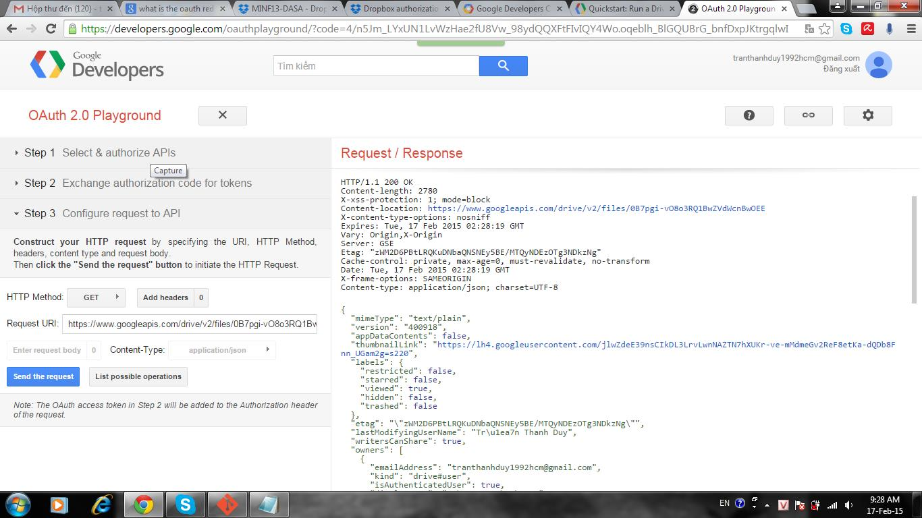

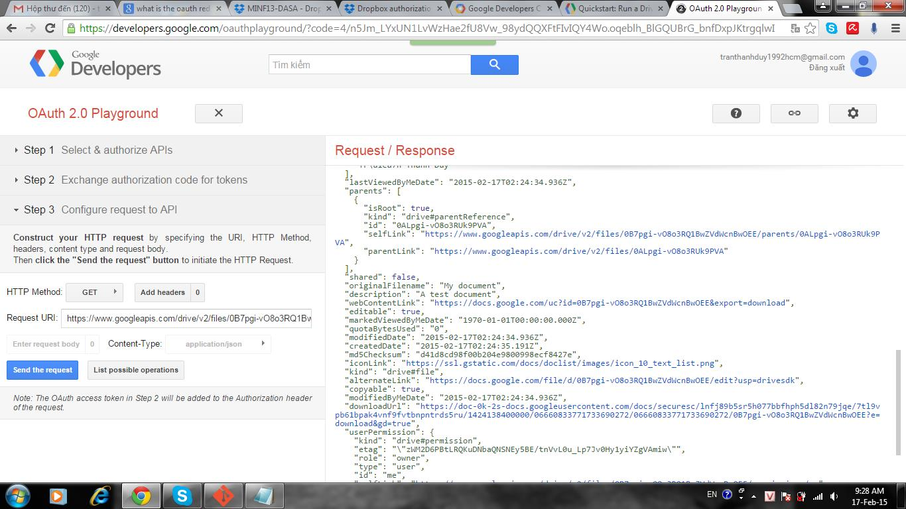

Step 2: Final result

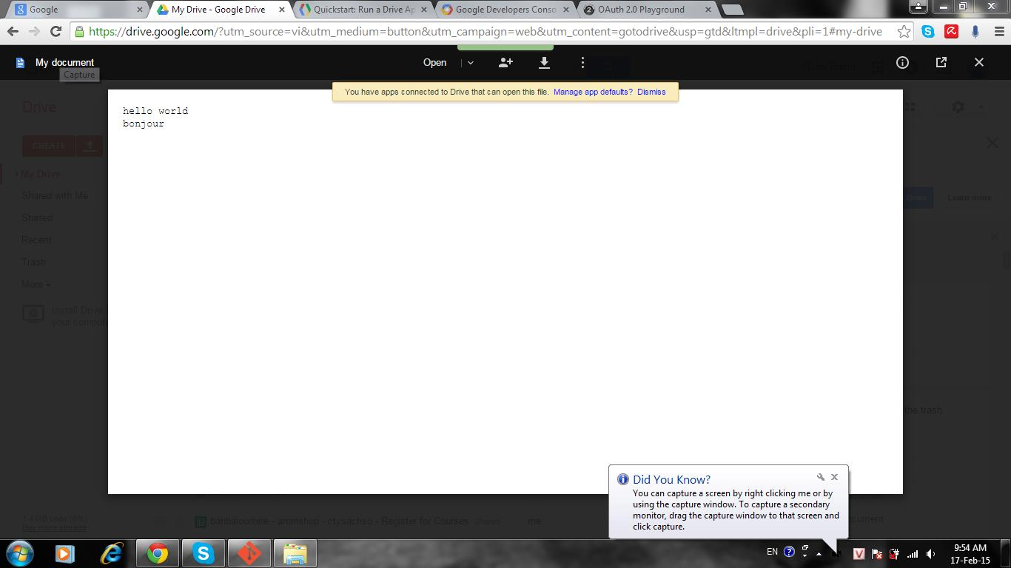

**Part 5: Difficulties**

Our team just has only difficultie, we can’t deploy the front-end side but all results is correct (we tested on Google Drive,…)